Blog 1 – for week 30/01/2023

For this week I started by doing some research into Image segmentation in Java as this seemed like one of the simpler ways to solve this problem. I spent a while researching as there wasn’t a lot of information for java specifically. I discovered OpenCV and started to play around with it for a while. To get a feel of the different algorithms. From what I found All the algorithms for image segmentation at least for Java aren’t ideal for this application. The images come out looking really choppy and others I’ve had a hard time actually getting to work at all.

As you can see its quite bad... Part of the reason its this bad is because my background is quite noisy. The project specification does say that I can use a static background, however in real life applications. I.e. a classroom it is unlikely for this to be the case

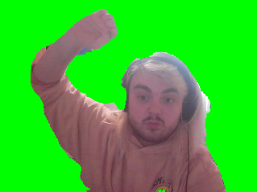 So After specking with Hannah it would be in my best interest to learn Python for this task at in the end will save me a lot of time. Switching to python also grants me a lot more opportunities when it comes to libraries like Mideapipe. Another recommendation from Hannah I would like to try is mapping out the skeleton of the person in the shot. This would allow me to remove the background a lot easier and also let the user do more dynamic shots hopefully.

This is an example of image segmentation in Python. This one clearly came out better than the one in java. If my plans for using skeletons fails ill uses this as my backup

In the Next week I would like to achieve the following

* Familiarise myself with Python
* Test out Mideapipe, Do research into it and get a prototype working for skeleton mapping
* Finish off my Project Outline.